**LEEA ACADEMY**

**TRAINING COURSE PROSPECTUS**

**January – June 2022**

Document reference LEEA 036(a) Version 2 October 2021

**LEEA Academy**

**COURSES**

* LEEA Foundation Course

This course is a pre-requisite that must be achieved before progressing to the LEEA Advanced Programmes. This course does not qualify students to inspect equipment.

* Lifting Equipment General Advanced Programme
* Lifting Machines Manual Advanced Programme
* Lifting Machines Power Advanced Programme
* Offshore Container Examination Advanced Programme
* Overhead Travelling Cranes Advanced Programme
* Runways & Crane Structures Advanced Programme
* Mobile Crane Examination Advanced Programme

These are specialist courses focussing specifically on different areas of lifting equipment as outlined in their syllabuses below. The Advanced Programmes can be taken in any order, and employees of our LEEA Full or Development Members are entitled to a LEEA TEAM Card in the category of “Test and Examine”, this will list all qualifications achieved.

**METHODS OF TRAINING**

**E-Learning** is available via our LEEA Academy for all LEEA Courses

**Instructor-Led Training (ILT)** courses can be delivered UK wide or internationally at our members’ premises, or at our purpose-built training centre in LEEA Huntingdon. Courses include the LEEA Foundation Course, and Advanced Programmes

**Hybrid** courses from our Huntingdon training centre will contain both in-class and students attending via Zoom. All students will be able to interact across our state-of-the-art audio-visual platform throughout the course

**Zoom** courses are also available and these are instructor-led via zoom teleconference. The Zoom courses are delivered over 4 consecutive days for Foundation, and 5 consecutive days for Advanced Programmes.

Our Mobile Cranes Examination course is only available to study via e-Learning and the course syllabus can be viewed on the following, <https://leeaint.com/course-details/courses-mce-mobile-crane-examination-advanced-programme>.

For information on all LEEA Training Services please email [academysupport@leeaint.com](mailto:academysupport@leeaint.com)

**FOU - LEEA FOUNDATION COURSE**

The course is structured to take place over a 4-day period and includes all equipment in the syllabus scope for the LEEA Advanced Programme courses.

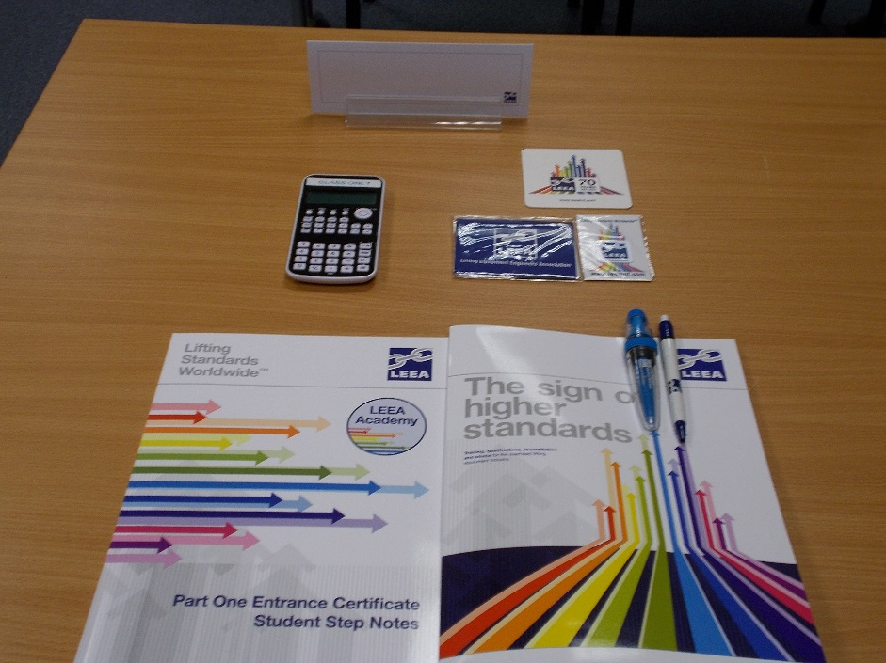**Course Syllabus:**

|  |  |  |  |
| --- | --- | --- | --- |
|  | Legislation  Standards & Codes of Practice  Materials  Basic Heat Treatment  Units of Measure  Basic Force, Stress and Strain  Basic Mechanics of Simple Machines  Methods of Manufacture  Verification of Lifting Equipment  Wire Rope & Wire Rope Slings  Chain & Chain Slings  Rating and Marking of Lifting Equipment  Textile Slings - Fibre Rope & Fibre Rope Slings |  | Textile Webbing Slings  Textile Roundslings  Components for slings  Shackles and eyebolts  Turnbuckles  Manual chain hoists  Lever hoists  Jaw winches  Jacks  Crane forks and C Hooks  Powered Lifting Machines  Runways and Crane Structures  Overhead Travelling Cranes  Offshore Containers  Mobile Cranes |

**LEG - LIFTING EQUIPMENT GENERAL ADVANCED PROGRAMME**

The course is structured to take place over a 5-day period where the delegates will benefit from hands-on practical training to complement the essential theory sessions. The Advanced Programme is based on lifting accessories and includes thorough examination procedures and criteria for continued periods of service.

**Course Syllabus:**

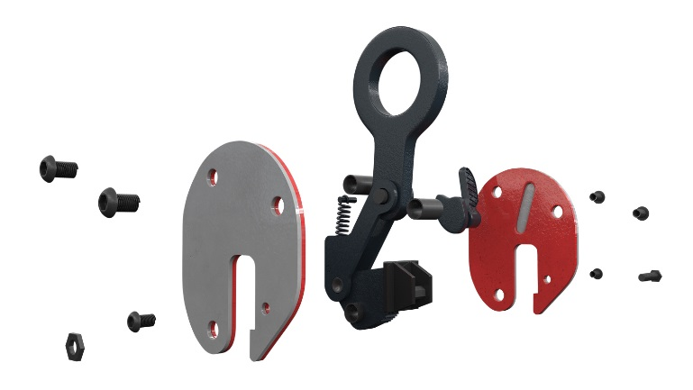

|  |  |  |  |  |  |  |
| --- | --- | --- | --- | --- | --- | --- |
|  | Legislation  Heat Treatment  Stress and Strain  Chain and Chain Slings  Wire Rope and Wire Rope Slings  Verification of Lifting Equipment  Textile Slings – Fibre Rope and Fibre Rope Slings  Textile Webbing Slings  Textile Roundslings | |  | | Components for Slings  Shackles and Eyebolts  Turnbuckles  Plate Clamps  Beam Clamps  Lifting Beams  Lifting Magnets  Vacuum Lifters  Crane Forks and C Hooks | |
|  | |  | |  | |  | |
|  | |  | |  | |  | |

**LMM - LIFTING MACHINES MANUAL ADVANCED PROGRAMME**

The course is structured to take place over a 5-day period where the delegates will benefit from hands-on practical training to complement the essential theory sessions. The Advanced Programme is based on manually operated lifting machines and includes thorough examination procedures and criteria for continued periods of service.

**Course Syllabus:**

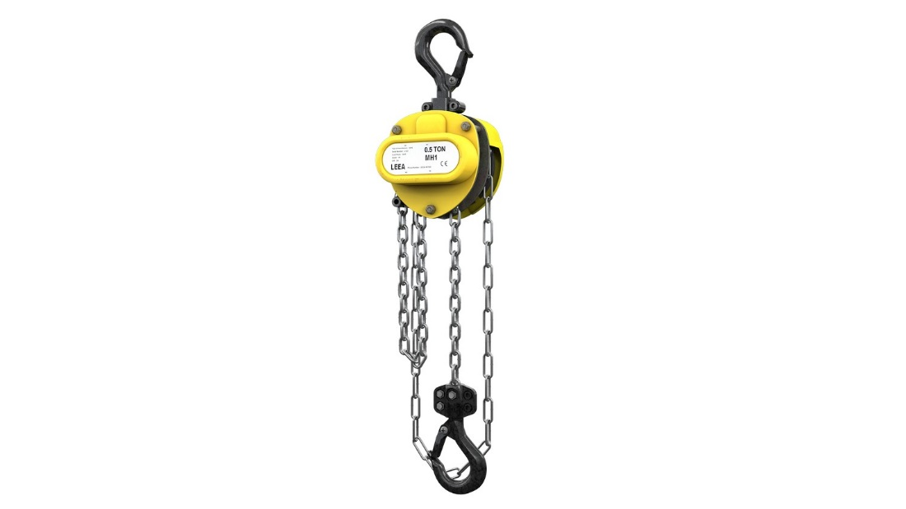

|  |  |  |  |
| --- | --- | --- | --- |
|  | Legislation  Mechanics – Simple Machines  Verification of Lifting Equipment (Testing & Examination)  Load Chain for Lifting Machines  Wire Rope for Lifting Machines  Screw Brake Mechanisms  Hand Operated Chain Blocks  Lever Hoists |  | Jaw Winches  Hand Operated Winches  Travelling Trolleys  Mechanical Jacks  Hydraulic Jacks  Pulley Blocks  Site Examination Procedures |

**LMP - LIFTING MACHINES POWER ADVANCED PROGRAMME**

The course is structured to take place over a 5-day period where delegates will benefit from hands-on practical training to complement the essential theory sessions. The Advanced Programme is based on powered lifting machines and includes thorough examination procedures and criteria for continued periods of service.

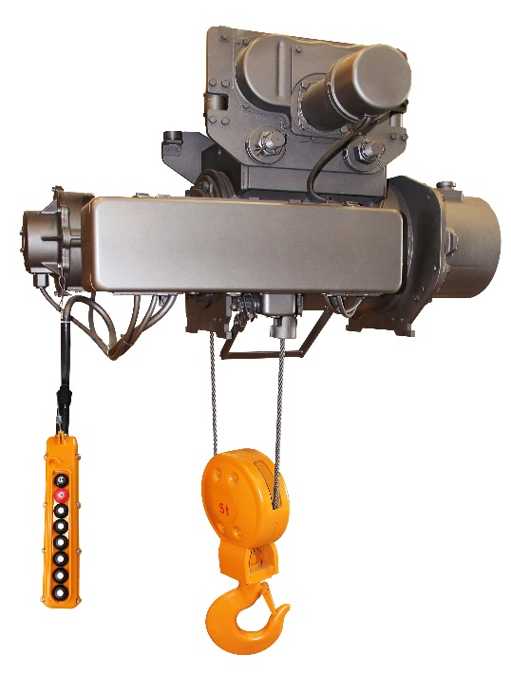

**Course Syllabus:**

|  |  |  |  |
| --- | --- | --- | --- |
|  | Legislation  Lifting Media – Chain  Lifting Media – Wire Rope  Load Hooks and Sheave Blocks  Suspension and Trolleys  Principles of Electrical Machines  Principles of Pneumatic Machines  Power Supply Systems  Electric Chain Hoists | Electric Wire Rope Hoists  Pneumatic Hoists  Powered Winches  Brakes  Limit Switches – Over travel  Overloading Protection – WLL  Overloading Protection – Electrical  Safe use of Powered Hoists |  |

|  |  |  |  |
| --- | --- | --- | --- |
|  |  |  |  |

**RCS - RUNWAYS & CRANE STRUCTURES ADVANCED PROGRAMME**

The course is structured to take place over a 5-day period. The Advanced Programme is based on runway beams, jib and mobile gantry cranes and structures, including thorough examination procedures and criteria for continued periods of service.

**Course Syllabus:**

Legislation Purpose built runways

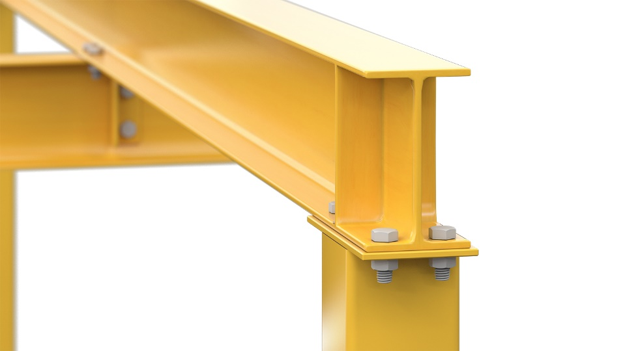Standards Cranes and components

Runways Beam clamps

Supporting Structures Mobile lifting gantries

Deflection and measurements Swing jib cranes

Runway beams with cantilevers Davits

Runway beam fixings – Bolted Examination and testing of slewing jib cranes

Welding of structural steel Power feed systems

Inspection and testing of welds Safety essentials – Working on RCS

Site examination and testing

**OTC - OVERHEAD TRAVELLING CRANES ADVANCED PROGRAMME**

The course is structured to take place over a 5-day period. The Advanced Programme focuses on overhead, portal and semi-portal cranes and includes thorough examination procedures and criteria for continued periods of service.

**Course Syllabus:**

|  |  |  |  |
| --- | --- | --- | --- |
|  | Legislation  Standards  Lifting Media – Load chain  Lifting Media – Load rope  Materials  Crane construction  Crane configuration  End carriages  Hoist construction  Rope drums and pulleys |  | Motion limit switches  Overload devices  Braking systems  Electric motors and VFDs  Duty classification  Safety essentials – Working on OTCs  Testing as part of the Thorough Examination  The Thorough Examination  Gantry alignment |

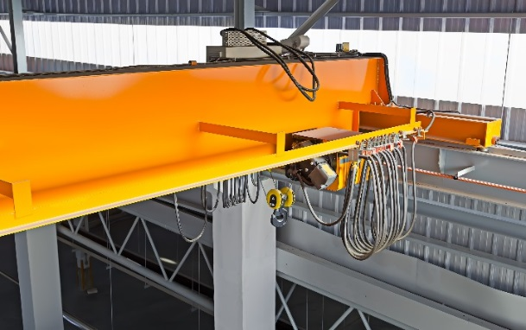  
 Power feed systems

**OCE - OFFSHORE CONTAINERS ADVANCED PROGRAMME - (DESIGN, CONSTRUCTION, TESTING, EXAMINATION & MARKING)**

The course is structured to take place over a 5-day period and will provide theoretical training in relation to the current regulations, standards and the requirements of persons carrying out testing, examination and marking of offshore containers with an overview of design and construction requirements.

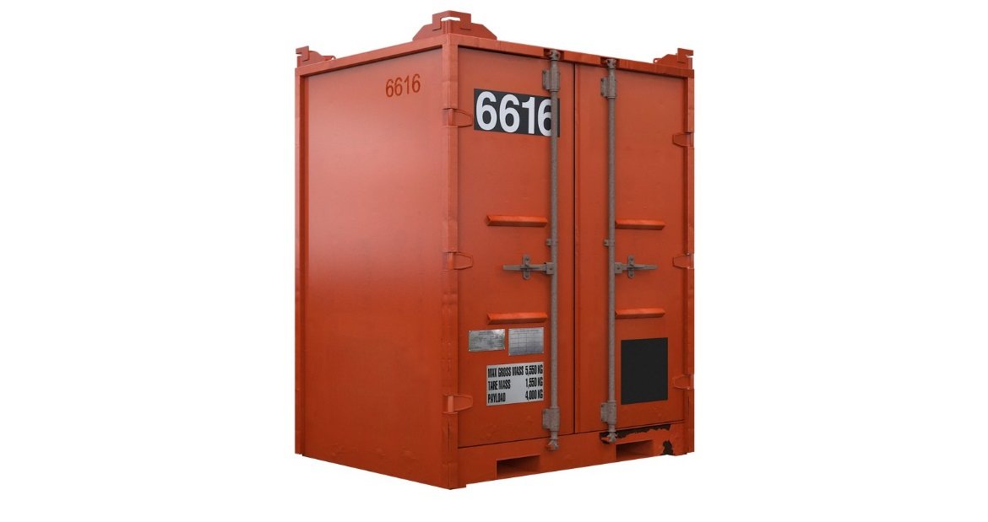**Course Syllabus:**

Legislation Shackles

Standards and Codes of Practice Lifting Set Design

Terms and definitions Examination of Containers

Design and Construction Examination of Lifting Sets

Pad Eyes Testing of Containers

Marking Requirements and Data Plates Testing of Lifting Sets

Certification Inspection Report Requirements

Chain Slings Pre-Trip Inspections

Steel Wire Rope Slings

**LEEA Huntingdon Training Centre Timetable (January – June 2022)**

**(H)** = Hybrid (this form is for a face-to-face booking, but students will also be attending the course via zoom)

|  |  |  |  |  |  |  |  |  |  |
| --- | --- | --- | --- | --- | --- | --- | --- | --- | --- |
| **Code** | **Course Title** | **Course Length** | **Jan** | **Feb** | **Mar** | **Apr** | **May** | **Jun** | **Price per delegate *(excluding VAT)** |
| **FOU** | LEEA Foundation Course | **3 days** | **4th – 7th (H)**  **10th – 13th (H)**  **17th – 20th (H)**  **31st – 3rd Feb (H)** | **14th – 17th (H)**  **28th – 3rd Mar (H)** | **7th – 10th (H)**  **21st – 24th (H)** |  |  |  | **£435.00** |
| **LEG** | Lifting Equipment General Advanced Programme | **5 days** | **24th – 28th (H)** | **7th – 11th (H)** |  | **25th – 29th** | **23rd – 27th (H)** | **20th – 24th (H)** | **£765.00** |
| **LMM** | Lifting Machines Manual Advanced Programme | **5 days** | **24th – 28th (H)** | **21st – 25th (H)** | **14th – 18th** |  | **16th – 20th** | **6th – 10th (H)** | **£765.00** |
| **LMP** | Lifting Machines Power Advanced Programme | **5 days** |  |  | **21st – 25th** |  |  | **6th – 10th** | **£765.00** |
| **RCS** | Runways and Crane Structures Advanced Programme | **5 days** |  |  | **7th – 11th** | **4th – 8th** |  |  | **£765.00** |
| **OTC** | Overhead Travelling Crane Advanced Programme | **5 days** | **24th – 28th** |  |  |  |  | **27th – 1st Jul** | **£765.00** |
| **OCE** | Offshore Container Advanced Programme | **5 days** |  |  | **14th – 18th** |  |  |  | **£765.00** |

**IMPORTANT INFORMATION REGARDING THE COURSES**

* The FOU (Foundation) course is held over 4 days and will commence at 08:30am and finish at 4:30pm (Monday to Thursday). When this course is scheduled to start on a Tuesday, the hours are as above, excluding Friday when it will be 08:30am to 3:00pm.
* All other courses will commence at 08:30am and finish at 4:30pm (Monday to Thursday) and 08:30am to 3:00pm at the latest (Friday). The timings throughout the week may change depending on group progress but this will be communicated by the trainer.
* For hybrid course dates, please note that the final assessment must be booked via the online assessment portal. This is to ensure that all students on these courses sit the same assessment method. Details on how to book these will be provided with the joining instructions, along with the booking form.
* Whenever possible we will endeavour to provide training on the preferred dates selected on the booking form. However, places will be allocated on a first come basis. Please therefore indicate any acceptable alternative dates.
* Lunch: students are asked to bring their own lunch as this is no longer provided due to COVID 19 risk control measures in place. A free of charge drinks vending machine is provided for use throughout the day together with filtered and chilled freshwater towers. There is a range of local food outlets available within a 5-minute drive of the training centre.
* The Advanced Programme training courses include a mixture of classroom and workshop sessions. Workshop sessions will involve handling equipment. Delegates should therefore be cleanly dresses and bring a suitable overall and safety footwear for the practical sessions. Hand tools will be provided and it will be the responsibility of the delegate to ensure that all tools and equipment are returned to their respective location at the end of the practical sessions.

# **LIFTING EQUIPMENT ENGINEERS ASSOCIATION - TRAINING COURSES BOOKING FORM Jan – Jun 2022**

PLEASE NOTE THAT LEEA MEMBERS **MUST** ONLY NOMINATE THEIR OWN EMPLOYEES FOR ANY LEEA TRAINING - IF LEEA DISCOVER THAT NON-EMPLOYEES ARE IN ATTENDANCE, THEY WILL **NOT** BE PERMITTED TO CONTINUE WITH THE TRAINING COURSE AND **NO** CERTIFICATES WILL BE ISSUED

**Students Details**

Given Name: Click or tap here to enter text. Family Name: Click or tap here to enter text.

Date of Birth: Click or tap here to enter text. LEEA Student ID (if known): Click or tap here to enter text.

Learning Difficulties

Does your delegate have any additional learning needs e.g., Dyslexia, if yes, please tick the box and provide details when submitting the form. This information will be held in the strictest confidence

**Company Details**

Company Name (and Branch if applicable): Click or tap here to enter text.

Address: Click or tap here to enter text.

Training Contact:

Training Contact Phone Number: Click or tap here to enter text.

Training Contact Email address: Click or tap here to enter text.

xx

**PLEASE SELECT THE COURSE BELOW INCLUDING THE PREFERRED DATE**

|  |  |  |
| --- | --- | --- |
| **Title** | **Course Name** | **Insert an ‘X’ as required** |
| FOU | LEEA Foundation Course |  |
| LEG | Lifting Equipment General Advanced Programme |  |
| LMM | Lifting Machines Manual Advanced Programme |  |
| LMP | Lifting Machines Power Advanced Programme |  |
| RCS | Runways and Crane Structures Advanced Programme |  |
| OTC | Overhead Travelling Cranes Advanced Programme |  |
| OCE | Offshore Containers Examination Advanced Programme |  |

As we are also running Hybrid courses (some students attending in person and others attending via Zoom) we are not taking any bookings via the website or listing the availability.

Please send your booking form back to [academysupport@leeaint.com](mailto:academysupport@leeaint.com) selecting your preferred dates below and a member of the team will be in touch to confirm the availability and booking.

**Preferred course start date:** (    /    /    ) **Alternative course start date:** (    /    /    )

Purchase order number: Click or tap here to enter text.

Name of person placing order: Click or tap here to enter text.

**Terms and Conditions**

**ELIGIBILITY FOR TRAINING**

* Trainees must be 18 years or older.
* Trainees must be employed by a LEEA Member or registered with LEEA as an Individual Trainee.
* Trainees must have passed the LEEA Foundation or previous Part 1 Entry course to complete an Advanced Programme.

**LEARNING DIFFICULTIES**

LEEA must be informed at the time of the booking, if a trainee has any additional learning needs, e.g., Dyslexia. The trainee should also inform their trainer at the start of the course. All such information will be in held in strictest confidence.

Depending on what assistance and accessibility arrangements are requested, we may need to see evidence of the trainee’s learning difficulty. Examples of evidence could include:

* A letter or report from a relevant medical practitioner such as a hospital consultant, psychiatrist, educational psychologist, Speech and Language therapist
* A statement of Special Educational Needs
* An Education, Health and Care Plan

Evidence submitted to us must be dated, include details of the author (like their name and position) and specify the disability or learning difficulty. The trainee should have been at least 12 years old when the evidence was written. The evidence should be relevant to the request (for example, if applying for a reader and no other arrangements, then results of a spelling test should not be included).

**PAYMENT TERMS**

Payment is required in full ahead of the course start date and joining instructions will not be issued until payment is received.

Please note that any courses booked within 35 days of the course start date must be paid at the time of booking, courses outside of this period can be invoiced but payment is required on receipt of the invoice or within our strict 30-day payment terms.

If you have made a booking pending payment, the below cancellation terms will still apply to this booking.

No member shall re-sell places on LEEA training courses to other companies or individuals.

All payments should be made in Pounds Sterling net of all currency charges.

**CANCELLATION – TRAINEE NO LONGER ATTENDING**

If you cancel the booking or fail to show for the course, refunds will not be given. If the invoice has not been paid, or the booking is cancelled within the below policies we will invoice for the appropriate cancellation fee.

Credit notes or transfers to alternative courses would be available in this event in line with our cancellation periods stated below.

Cancellation within 7 working days of the commencement of the course = 50% of the course fee

Cancellation within 2 working days of the commencement of the course = 100% of the course fee

**SUBSTITUTIONS**

If a delegate becomes unavailable before the commencement of the course, a substitute may be nominated. Substitution once the course has commenced is not accepted.

**CANCELLATION – COURSE NO LONGER RUNNING**

LEEA reserves the right to postpone or cancel a course if the number of trainees or operational demands mean that it is not viable to run the course.

Delegates are strongly advised to book accommodation that may be changed or refunded due to the unlikely event that LEEA has to postpone or cancel a course for operational reasons. LEEA will not be responsible for lost deposits or cancellation charges.

**ASSESSMENT RESULTS, CERTIFICATES AND TEAM CARDS**

Assessments are subject to initial marking, followed by verification. The results are processed on our database, certificates, and TEAM cards (where applicable) printed where required and prepared for dispatch. Finally, a notification of results is emailed to the nominated LEEA / Training contact of a member company directly. Hard copies are sent to Head Office addresses held in our database. **Subject to annual subscription fees having been paid.**

**Credit/Debit card payment:**

Please complete the details below. Card type (please indicate):

MasterCard, Visa Credit, Visa Electron, Maestro, Solo, JCB, American Express, Visa Debit

Card number: Click or tap here to enter text.

Card expiry date: Click or tap here to enter text.

Security code (last 3 digits in signature box): Click or tap here to enter text.

Issue number or start date (Maestro/Solo only): Click or tap here to enter text.

Card holder’s name (as on the card): Click or tap here to enter text.

Card holder’s Signature:

Alternatively, we can issue you with a secure payment link or take payment via the phone +44 1480 432801.

**How to find us**

Huntingdon is in Cambridgeshire, approximately 60 miles due North of central London. It is easily accessible by major road and rail networks and within a reasonable distance of London’s international airports.

Due to resent road upgrades your sat nav may try and direct you the previous way to our training centre. We recommend leaving the A14 or A1 when you see signs for Huntingdon Racecourse and your sat nav should then pick up the usual route.

**By rail**

The nearest station is at Huntingdon and is on the main line North from London’s Kings Cross terminus. Taxis are available at the station.

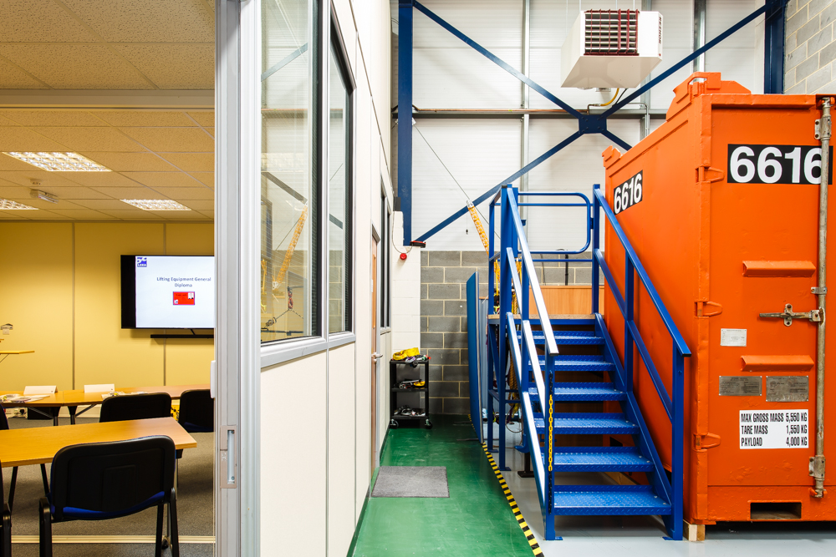

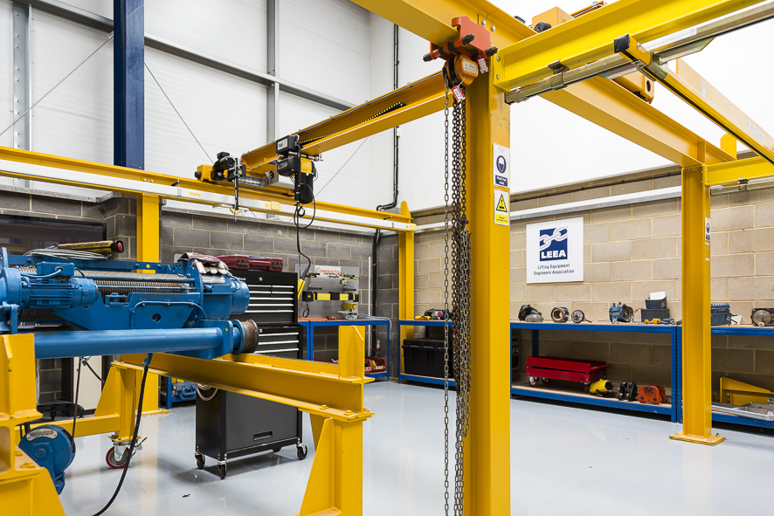

Huntingdon Training Centre