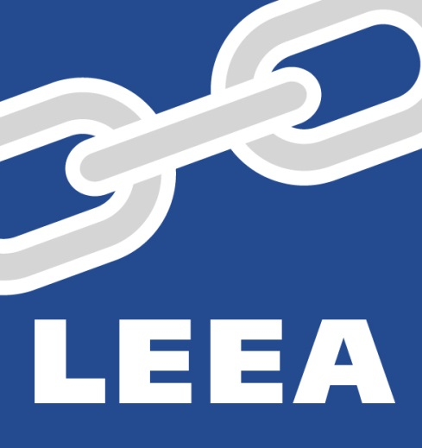

C.M.T.E
(Combined Member Training Event)
SCOTLAND
4th – 6th March 2020
&
9th – 13th March 2020

LEEA Combined Member Training Event
SCOTLAND – MARCH 2020

Dear Member

LEEA proposes to hold a Combined Member Training Event in Scotland during March 2020. The courses include LEEA Instructor led training, training materials and final assessments.
Further details of the training location and arrangements will be forwarded to you once we confirm bookings.
Please note that minimum numbers are required in order that any of the training courses are held and we reserve the right to cancel or amend any part of this program if these are not met.
PLEASE NOTE THAT LEEA MEMBERS MUST ONLY NOMINATE THEIR OWN EMPLOYEES FOR ANY LEEA TRAINING - IF LEEA DISCOVER THAT NON-EMPLOYEES ARE IN ATTENDANCE, THEY WILL NOT BE PERMITTED TO CONTINUE WITH THE TRAINING COURSE AND NO CERTIFICATES WILL BE ISSUED
Training Courses Prices
- For COMPANY MEMBERS* the training courses are priced as follows:
LEEA Foundation Course £520 GBP per delegate per course
LEEA Advanced Programme £870 GBP per delegate per course
- For INDIVIDUAL TRAINEES* the training courses are priced as follows:
LEEA Foundation £1040 GBP per delegate per course
LEEA Advanced Programme £1740 GBP per delegate per course

Course Training Specialist:
Scott Barnes – LEEA Training Specialist

Please Note:
All courses will strictly commence at 08.30am each day.
Trainees wishing to attend an Advanced Programme course must have already passed the LEEA Foundation Course (P1E).
Bookings must be returned by 18th February 2020 at the latest. Any bookings received after this date cannot be guaranteed.

Number of places requested
Please indicate the number of places you are interested in booking for your Company in the table below:
Company Name____________________________________________________________
Members Authorized Signature_______________________________________________

Course | Venue | Course Dates | Number of places required | * Price per Delegate | Total Course Price £ GBP
LEEA Foundation Course | Aberdeen TBC | 4th – 6th March |  | £520.00 (Member)  £1040 (Individual)
Lifting Equipment General Advanced Programme | Aberdeen TBC | 9th – 13th March |  | £870.00 (Member)  £1740 (Individual)
TOTAL AMOUNT PAYABLE |  |  | £
(*Delete as appropriate Member Rate or Individual Trainee Rate)
Delegates Name | LEEA Member Company | Course
Method of Payment
Members will be immediately invoiced in full at time of booking. Payment in full will be due 15 days prior to the course date(s)
All individuals will be asked to produce official identification at course registration. Passports and official photo ID cards will be the only accepted form of identification.
Please return this booking form by e-mail to: cmtetraining@leeaint.com indicating the courses that you wish to attend and how many places on each course

TERMS AND CONDITIONS

Training Staff Air Fares - Included in course fees.

Training Staff Travel Visas & Inoculation Charges - Included in course fees.

Training Staff Local Transportation - Included in course fees.

Training Staff Hotel & Expenses - Included in course fees.

Printing - All training materials will be dispatched to training venues by the LEEA prior to the training event and will be marked strictly private and confidential for the attention of LEEA Training Staff.

Course Numbers - The maximum delegate numbers will be stated in the course schedules.

Practical Training Aids - Training aids may be required if appropriate to the venue. LEEA training staff will advise as appropriate.

Delegate Identification - All delegates will be asked to provide official photographic ID upon course registration (Passport, TEAM Card, Residents Permit, Driving Licence or other official document. This will be used strictly for LEEA database administration and will be subject to the LEEA confidentiality policy.

Member Cancellation - Training fees are non-refundable in the event of cancellation or non-attendance.

Force Majeure - Neither LEEA or the member shall be liable to the other for any failure to perform any part of the agreement which is due to an event beyond the control of either party, including but not limited to terrorism, war, Political insurgence, strike, riot, civil unrest, act of civil or military authority, uprising, earthquake, flood or any other natural or man-made eventuality which may cause the termination of the agreement.

Payment - Payment for training courses is payable 15 days before the start of the course.

Host Company Facilities - A suitable, risk-assessed training room with suitable desks and chairs will be provided. Dry white board, flipchart and digital projector will also be provided.

